Course on Internet of Things

Exercises Session 1:

Exercise 1:
Connect to your ESP32 with minicom or thonny.
Using REPL:
- print “Hello World!”
- read in a text using input() and print it
- Calculate
- Calculate sin(30°)
If you see errors, how do you correct them? Are the results correct?

Exercise 2:
Write a script that assigns the values 5 and 3 to the variables a and b respectively
Print the results of 4 basic arithmetic operations:
- a+b
- a-b
- a*b
- a/b
If you use integer format when printing the result, you will see the result truncated to an integer. Can you correct changing the format?
Improve this program asking the user to enter 2 real numbers (floats) separated by a space. This is how it should look like:
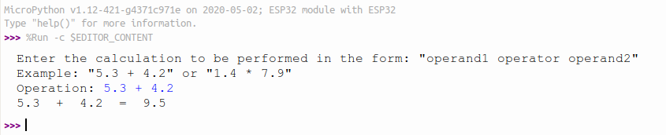

If this happens:
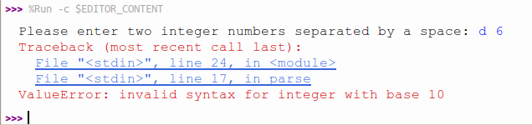
when the user mistypes and enters something that is not a real number?
Can you capture the error and simply ask him to repeat his input until you get 2 correct floating point numbers?
Bonus points: Writing a parser for user input is rather easy if the numbers and operator are separated by spaces (have a look at the split method of strings). It is quite a bit more tricky if you allow entering calculations without spaces between the operands and the operator. Can you write a parser accomplishing this?
Hint: A very elegant solution to this is the use of regular expressions and Python provides a module helping you with this: https://docs.micropython.org/en/v1.9.3/pyboard/library/ure.html
A float is defined as follows:
- zero or more spaces
- followed by one + or one -
- followed by
  - a ‘.’ followed by at least one digit
- or
  - at least one digit followed by zero or one ‘.’ followed by zero or more digits
- followed be zero of more spaces

Try your parser on this input:

Input | ok or not ok
5.3+4.7 | ok
5.3++4.7 | not ok
5..3 + 4.7 | not ok
.3+.7 | ok
5.3+4b7 | not ok
empty string | not ok
5.3+. | not ok
5.3+ | not ok
-1--1 | ok
--1--1 | not ok

Try also several spaces in between operands and operator.

Exercise 3:
Like in exercise2, start with 2 numbers a,b with values 5 and 7. In your program check which of the 2 numbers is bigger and print the result.
Then improve the program asking the user for 2 integer numbers. Make sure he enters 2 correct numbers and capture possible errors. This is a typical output:

Exercise 4: The Fibonacci series
The Fibonacci number series is defined as:
F(0) = 0; F(1) = 1
F(n) = F(n-1) + F(n-2)
- Calculate and print out the Fibonacci numbers up to F(n). Get n from the user where n >= 0
Try your program for n=0, n=1, n=2, n=3, n=20
- Ask the user up to which is the maximum number up to which you should calculate.

Exercise 5: A bit of Mathematics: Calculate the sine function
Write a script that asks the user for an angle in degrees. Calculate the sine of this angle.

Exercise 6: Classes
Write a Python class with methods calculating mathematical number series. These series should be calculated:
- The Fibonacci numbers up to F(n). n is passed as parameter to the method
- The Fibonacci numbers smaller than max. max is passed as parameter to the method
- The prime numbers up to max
- Factorial:
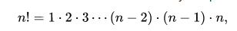
- The geometric number series:
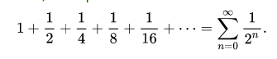
- The harmonic number series:
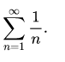
Can you tell what the following series calculate?

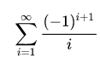 | 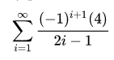 | 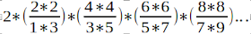 | 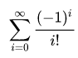
Add these series to your class and try. Write a test script exercising the different methods.
In order to make this exercise run on the ESP32 you must first upload your mathSeries.py module implementing the MathSeries class into the file system of the ESP32. Create a directory called lib on the ESP32 file system and put your module there:
ampy mkdir /lib
ampy put mathSeries.py /lib/mathSeries.py
Once this is done, go to the REPL window of thonny and
import mathSeries
You can now create an instance of the MathSeries class:
series = mathSeries.MathSeries()
When running on a PC you may want to plot the series as well. If you don't know how to plot data in Python, you will find all the information needed here:
https://matplotlib.org/3.2.1/index.html


